ELEC 1100 Laboratory 2: Summary Sheet

Name: __________________________ Student ID:

Notes:
(1) Show demo to your TA for an attendance record; bonus mark will be given to groups who can complete all TA Checks in the first 2 hours of your enrolled lab session.
LA2 (Fri, before 15:30), LA3 (Mon, before 12:30), LA1 (Tue, before 15:30)
(2) Individually submit your completed lab summary sheet to Canvas (LA1/LA2/LA3/LA4) “Assignments” before the deadline.
LA2 (Fri, deadline 16:20), LA3 (Mon, deadline 13:20), LA1 (Tue, deadline 16:20)

Experimental Results and Analysis

Q1: Calculate for R_{eq} and complete the table below.
Q2: Record the value of R_{eq} displayed on the screen (including the unit Ω/kΩ) to fill in the table below.
Figure 1 | Figure 2
B  A  2kΩ  1kΩ  R_{eq} | B  A  2kΩ  2kΩ  1.5kΩ  1kΩ  R_{eq}
By calculation:  R_{eq} =$1 kΩ+2 kΩ=3 kΩ$  (show your calculation steps) | By calculation:  $R_{eq}=2 kΩ+$1/(1/(1.5$kΩ$)+1/((2+1)$kΩ)$)  $$=3 kΩ$$  (show your calculation steps)
From the multimeter:  R_{eq} =2.977 $kΩ$≈3 $kΩ$  This value should match your calculation above. | From the multimeter:  R_{eq} =2.978 $kΩ$≈3 $kΩ$  This value should match your calculation above.
Q3: Based on what you got above, analysis a resistor network with infinite modules (R, 1.5R, 2R) as below. Prove that R_{eq} = 3R. Show clearly the calculation steps.
1.5R
R
2R
1.5R
1.5R
1.5R
R_{eq}
2R
2R
2R
2R
……

Using R=1000Ω to get Figure 2, the network consisting of the rightmost 4 resistors have an equivalent resistance of 3R. Now we consider adding 2 resistors (one of 2R, the other of 1.5R) in our calculations. We get:
R=2R+1/(1/(1.5R)+1/(3R))=2R+1/(3/(3R))=2R+R=3R
Since we always keep adding the same 2 resistors, the above calculations always apply and always produce 3R as equivalent resistance. Thus the network with infinite resistors as above has 3R as equivalent resistance.

Q4: Record the measurement of voltages V_{AD}, V_{AB}, V_{BC}, V_{CD} and V_{DA} to fill in the table below.
Q5: Complete the table to show that the sum of the voltages ACROSS all of the components (including the power source) in a loop complies with Kirchhoff’s voltage law (KVL).
V_{AD} | V_{AB} | V_{BC} | V_{CD} | V_{DA}
6.099 V | 1.351 V | 2.031 V | 2.714 V | -6.099 V
V_{AD} = V_{AB} + V_{BC} + V_{CD}
(use the measured voltages to verify the equation)
V_{AD} =6.099 V
V_{AB} + V_{BC} + V_{CD} =1.351+2.031+2.714=6.096 V≈6.099 V
V_{AB} + V_{BC} + V_{CD} + V_{DA} = 0
(use the measured voltages to verify the equation)
V_{AB} + V_{BC} + V_{CD} + V_{DA} = 1.351+2.031+2.714-6.099=-0.003 V≈0 V

Q6: Calculate for branch currents I₁, I₂ and I₃ to fill in the table below.
Q7: Record the value of I displayed on the screen (including the unit “mA”). Complete the table to show that the sum of currents complies with Kirchhoff’s current law (KCL).
I = I₁ + I₂ + I₃
By calculation:
I₁ = 6.01 mA I₂ = 4.01 mA I₃ =2.98 mA

I₁ + I₂ + I₃ =6.01+4.01+2.98=13 mA
From the multimeter:
Total current I = 12.98 mA≈13 mA
This value should match your calculation above.

Q8: Use KCL to solve the currents I, I₁ and I_{2,} then determine the voltage at node X in the cirucit below.
I₁
10V
6V
2kΩ
1kΩ
2kΩ
+
-
+
-
X
I
I₂

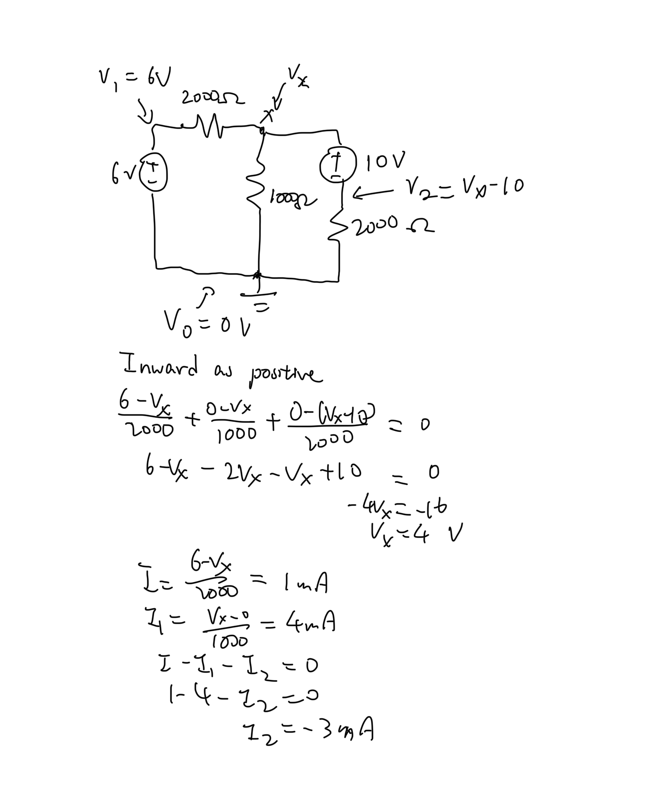
Show your calculation steps. **Notice the unit and direction of each value.
I = 1 mA I₁ = 4 mA I₂ = -3 mA V_{X} = 4V
Q9: Record the value of V_{X} from the multimeter to fill in the table below.
Q10: Record the value of I from the multimeter (including the unit “mA”) to fill in the table below.
From the multimeter:  V_{X} =4.064 V≈4 V  This value should match your calculated V_{X} in Q8. | From the multimeter:  I =1.01 mA≈1 mA  This value should match your calculated I in Q8.

Q11: Record the value of R_{eq} from the multimeter (including the unit Ω/kΩ) to fill in the table.
From the multimeter:
R_{eq} =1.801 kΩ

Q12: Record the voltages from the multimeter and fill in the table.
From the multimeter:  V_{C} = 4.741 V (versus GND) | From the multimeter:  V_{D} = 7.24 V (versus GND)

Q13: Record the value of I from the multimeter (including the unit “mA”) to fill in the table.
From the multimeter:
I = 5.51 mA

Q14: Based on your record in Q13, use Ohm’s law to calculate for R_{eq} to fill in the table.
By calculation (including the unit Ω/kΩ):
$R_{eq}=\frac{V}{I}=$10/0.00551≈1.81488203 kΩ≈1.801 kΩ
This value should match your measured R_{eq} in Q11.

